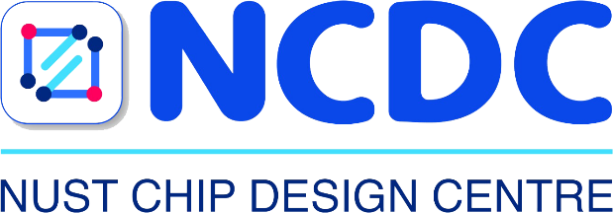

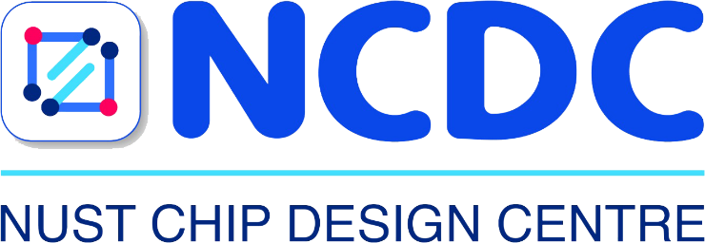

C / C++ Programming

Weekly Task # 01
Game of life

Name | Waleed Amir
Instructor | Engr. Hira Sohail
Date | 13th July 2025

- In-Lab Tasks: (Write your lab task & screenshots here)
- Task 1:
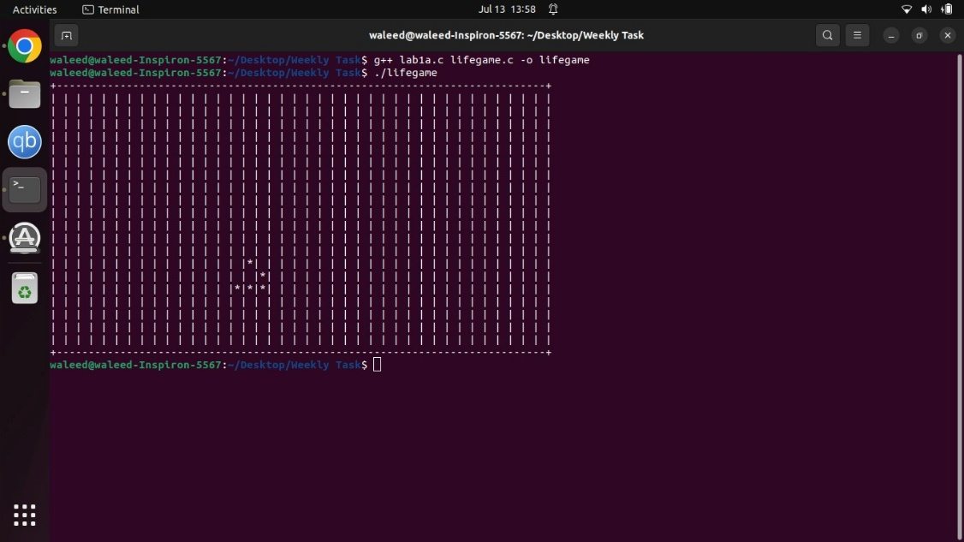

- Task 2:
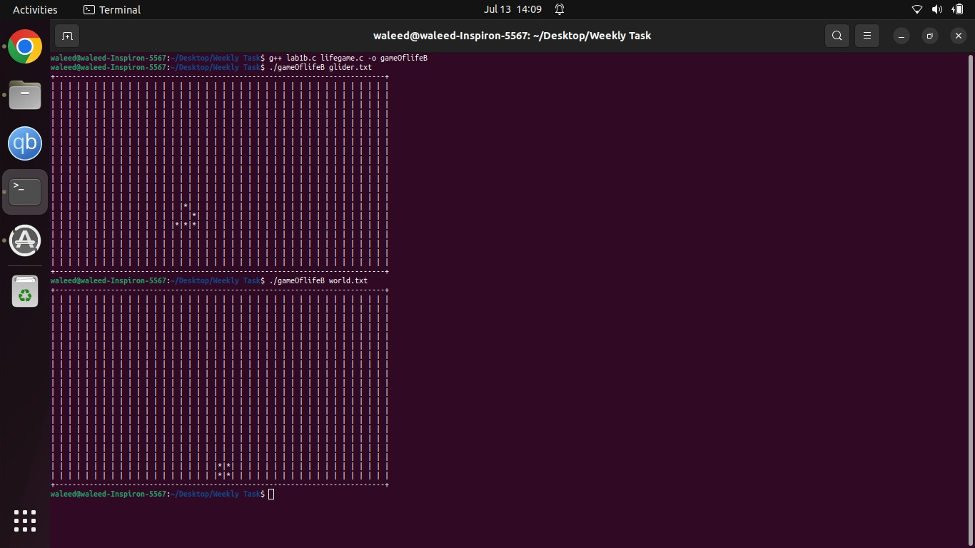

- Critical Analysis: (Write you critical analysis / conclusion here)
The main challenge in this task was understanding the coordinate system and how to handle the boundary conditions. The API design of the code really helped out in simplifying the logic. Furthermore, the input output implementation of the files needed particular attention to line handling and character encoding. Some of things I learned from this was 2D array manipulation which came in use for the coordinate system and neighbor calculations. Some of the problems in encountered in this was using nested loops including proper boundary checks, another challenge was translating Conway’s logic into conditional logic.

